The Area Character Assessment documents are intended to describe various parts of the parish in lay terms, rather than with technical accuracy. It is recognised that many details will not be included in order to be concise, and the level of detail may vary between areas due to how the contributions were collated.
Most descriptions are based on local observation, with the assistance of Google Maps, and any opinions stated are generally those of the authors and contributors.
What is considered small or large in terms of house or plot sizes are comparative to others in the local or wider areas on a general impression basis, rather than any actual measurements. Similarly with house prices, actual figures have not been sought.
(See below for some relevant figures if interested)
The descriptions of Public Rights of Way (PROW) are from observation. Full information regarding the PROW reference numbers and start and end points is available on-line on the South Gloucestershire Council’s PROW website, Map page:
https://rightsofway-southglos.esdm.co.uk/

Typical Google Maps page used in collating the Area Character Assessment information.
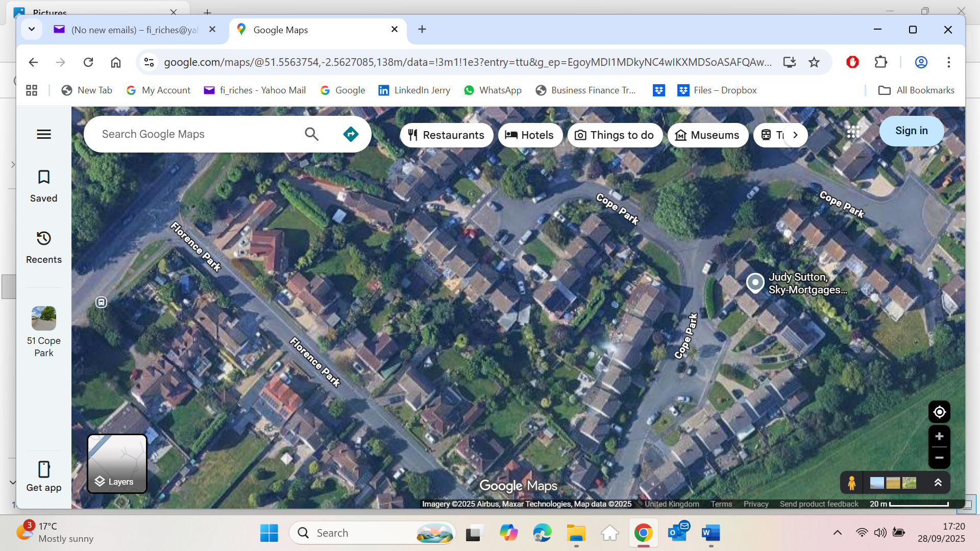

Some housing facts – accuracy is not guaranteed!
Prices
- The average house price in the UK in July 2025 was £270,000, GOV.UK House Price Index
- House prices in Almondsbury average £641,043 over 2024 Right Move
Size
- The average total floor area of a dwelling 94sqm in 2018-19 English Housing Survey GOV.UK
- A UK small home is legally required to be at least 37 sqm and "small house generally refers to a property that is under 93 sqm, with one to two bedrooms
- A typical UK semi-detached house averages 84 to 111 sqm, but for new builds 88 to 90 sqm and older homes 100 to 140 sqm
- Detached 4-bedroom houses average of around 147sqm, ranging from 120sqm to over 300sqm Google AI
- The UK homes average 2.95 bedrooms with detached houses averaging 4 bedrooms, semis 3 bedrooms, terraced 2 to 3 bedrooms and flats 1 to 2 bedrooms. Statista
Plots & Gardens
- The average total garden area (including front and side) for a UK home is approximately 256 sqm 2023 survey Horticultural Trades Association
- Decrease in average garden size from 168 sqm to 163.2 sqm between 1983 and 2013, along with an increasing number of homes lacking a private garden entirely Google AI and widely quoted
- However, compared to 10 years ago, gardens of new build detached homes are 18% larger today, semi-detached homes 20% larger and terraced houses 10% larger 10 August 2023 martyngerrard.co.uk
- The South West average garden sizes of 334 square metres Sep2023 Quick Move
- The UK average garden size is approximately 188 m² 2020 Office for National Statistics
- New-build houses’ gardens average size 113.4m² 8/2/2020 Wildlife Gardening Forum
- In Uk "large" generally a garden of 250 sqm or more could be considered large
- One in eight British households has no garden 2020 Office for National Statistics

