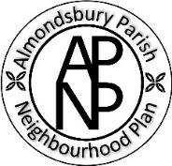
Almondsbury Parish Neighbourhood Plan
Business Survey
We have been emailing our Business Survey to businesses and companies which are registered and/or operate and/or have premises in Almondsbury Parish to engage and gather further views on how the Neighbourhood Plan should develop.

It is a key requirement to identify the people and groups who will be affected by the plan and provide them with the opportunity to have their say.
We recognise that we may have missed some businesses in our searches, especially the self-employed or part-timers. We have also had trouble finding some email contacts.
Therefore, we would be very grateful if anyone who owns or runs a business in the parish, who haven’t already done so, would fill in our on-line survey https://forms.gle/ykS1jCshsEiJRAqX7
It shouldn’t take too long! Closing date for the surveys is 9th February 2026.
Also, if you know someone who may have been missed, please would you forward the survey link to them.
Thank You
admin@almondsburyparishneighbourhoodplan.co.uk
