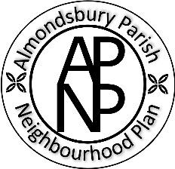
Almondsbury Parish Neighbourhood Plan
Business Survey
We are contacting you as your business/company is registered and/or operates and/or has premises in Almondsbury Parish.
Please see the map below to see the area the parish covers including Almondsbury, Cribbs Causeway, Easter Compton and Hallen.

The Almondsbury Parish Neighbourhood Plan (APNP) Steering Group is looking to engage with local businesses to gather views on how the plan should develop. A key requirement is to identify the people and groups who will be affected by the plan and provide them with the opportunity to have their say.
Therefore, we would be very grateful if someone from your company could fill in the survey – it shouldn't take too long! It can be found at

https://forms.gle/ykS1jCshsEiJRAqX7
Closing date for the surveys is 9th February 2026.
You can find out more about the APNP on our website https://almondsburyparishneighbourhoodplan.co.uk/
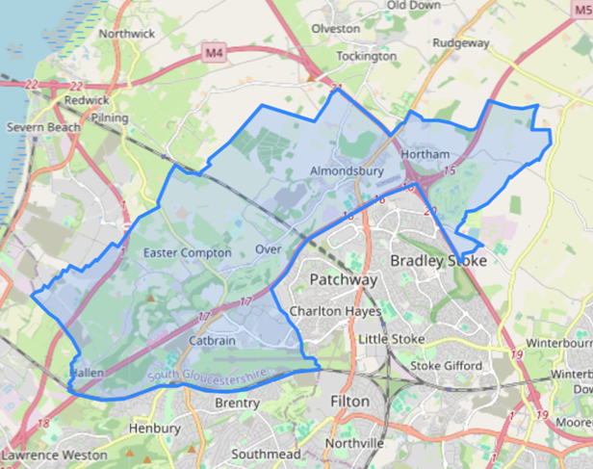
Many thanks.

admin@almondsburyparishneighbourhoodplan.co.uk

